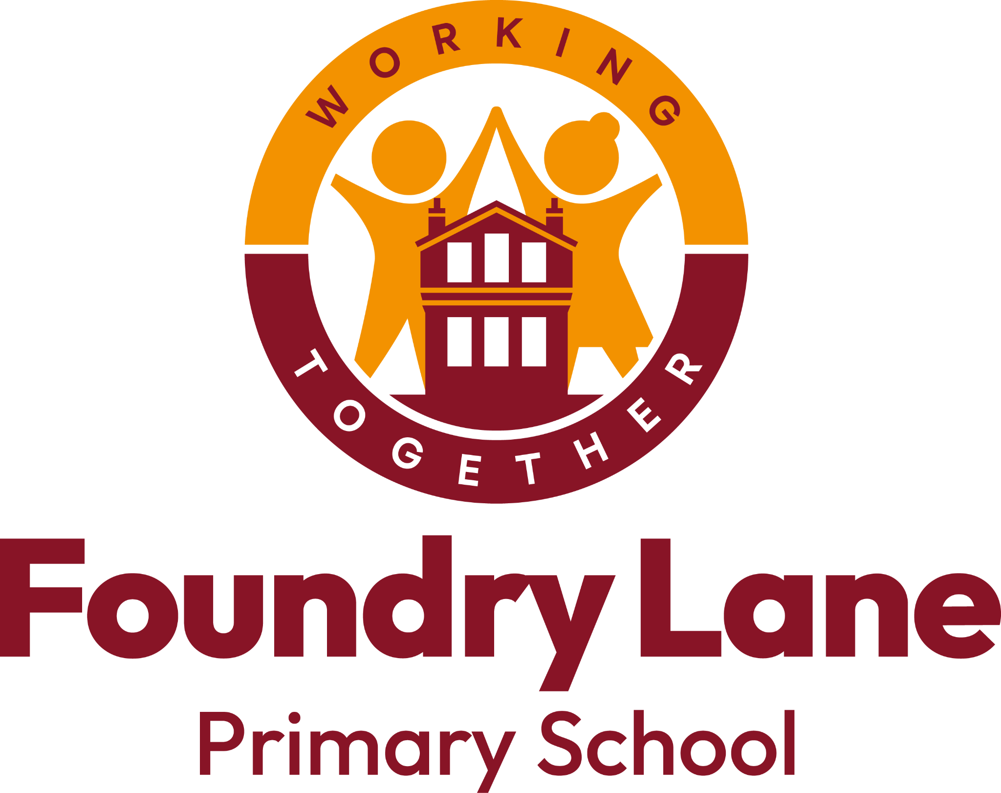
Music Development Plan Summary:
Foundry Lane Primary School

Overview
Detail | Information
Academic year that this summary covers | 2024 - 25
Date this summary was published | October 2024
Date this summary will be reviewed | October 2025
Name of the school music lead | Katie Flintoft
Name of school leadership team member with responsibility for music (if different) | Katie Flintoft
Name of local music hub | Southampton Music Hub
Name of other music education organisation(s) (if partnership in place)

This is a summary of how Foundry Lane Primary school delivers music education to all our pupils across three areas – curriculum music, co-curricular provision and musical experiences – and what changes we are planning in future years. This information is to help pupils and parents or carers understand what our school offers and who we work with to support our pupils’ music education.
Our Curriculum Intent
At Foundry Lane Primary School music is accessible to all children in our community irrespective of race, gender, social background or religion.
The teaching of Music is prioritised as a subject in its own right but is also often embedded into the wider curriculum including: English, art, humanities and science. Music has an essential place in our curriculum as it can influence and provide cultural capital for all pupils.
Music has an integral place in our school community as it offers opportunities for children to express their creativity, develop independence and show resilience when working on a particular element of music.
Music is seen as a shared experience, where children can learn, compose and perform with others; this happens not only within their class or year group, but also with children of different ages in assemblies and through musical opportunities within and outside of school. These shared musical experiences help to develop, encourage and embed kindness and social skills. In Music lessons, all children, especially those with vulnerable backgrounds have the opportunity to thrive and achieve their full potential.
In Music, children have the opportunity to build on their knowledge, critical thinking and awareness of other cultures, music and traditions. They have the chance to see how society has changed through a musical lens.
Children will have the opportunity to become immersed with a wide range of music as well as having the opportunity to have hands-on learning with instruments within and across both key stages.
We ensure that provision is developed and accelerated through using music specialists from their particular field including beat boxers and peripatetic teachers. In Year 4, all children learn to play an instrument each term, giving them the opportunity for a unique learning experience.

Part A: Curriculum music
This is about what we teach in lesson time, how much time is spent teaching music and any music qualifications or awards that pupils can achieve.

Curriculum Music

Musical events and opportunities

Instrumental and vocal lessons and ensembles

National Curriculum is taught in KS1 and KS2
In the Early Years the Foundation Stage Curriculum is taught.
Each year group has half termly projects, each with subject knowledge and skills to be taught. At times, these projects may be taught as a block.
At Foundry Lane Primary School, the music curriculum is taught through weekly 60 minute class music lessons in Year 1 – 6 This is usually delivered by the class teacher and is informed by the Model Music Curriculum (March 2021)

Singing

Listening

Composing

Performing

The National Curriculum for Music is taught through subject specific projects which explore the seven dimensions of music: pitch, duration, dynamics, tempo, timbre, texture and structure. Where appropriate, there is opportunity for children to apply their understanding through the skills of: singing, playing, notation, listening and responding, rehearsing and performing, describing and discussing. At Foundry Lane Primary School, the music curriculum is mapped out through learning pathways.
Singing is at the heart of Key Stage 1, with songs and chants underpinning all areas of study. Pupils will build musical confidence through active engagement with music as performers, music-creators and audience. There are frequent informal opportunities to perform. The key skills and techniques learnt in Key Stage 1 are built on and prepare pupils for progression through Key Stage 2 and while singing remains a key thread throughout Key Stage 2 the curriculum at Foundry Lane Primary School supports other aspects of music making – in particular, the opportunity to access and make progress on a musical instrument. Links with our partners Southampton Music Hub.
Inclusion
To meet the needs of all our children we teach music through an inclusive music curriculum. We have identified the barriers for some children. These include being unable to easily listen and appreciate; experiencing disadvantage and physical or learning difference. Our aim is that children will be to be able to listen to and identify with music that generates a response from them. Every child is entitled to a music curriculum that is adapted to their individual needs, as required, including making use of pupil premium funding. We are determined to tackle the divide between the opportunities for children whose families can afford to pay for music tuition and for those who come from lower socio-economic backgrounds.

Part B: Co-curricular music
This is about opportunities for pupils to sing and play music, outside of lesson time, including choirs, ensembles and bands, and how pupils can make progress in music beyond the core curriculum.
At Foundy Lane Primary School, all children are offered a range of instrumental lessons. Children can learn the following:
- Brass (trumpet, baritone horn, tenor horn)
- Woodwind (flute, clarinet)
- Strings (violin)
- Percussion (drum)
- Guitar
- Keyboard

Individual and paired tuition
Children are taught individually or in small groups for 20- 30 minute sessions. Lessons are provided by Southampton Music Service specialist teachers. The cost of lessons is £5 per lesson, and is already subsidised.

Choir
We have a popular Foundry Lane Choir that meets weekly after school and is free to join. The choir performs at various concerts in and out of school. Choir sessions include:
Warm ups; Breathing; Posture; Dynamics; Phrasing; Context; Vocal health

Productions
Singing is promoted throughout the school. Children enjoy singing in whole school productions, including the Nativity, the Christmas visit to Shirley Baptist church and the year 6 Summer Production. All children participate and the benefits extend beyond the experience of singing to boosting emotional well-being.

Part C: Musical experiences
This is about all the other musical events and opportunities that we organise, such as singing in assembly, concerts and shows, and trips to professional concerts.
We want the love of music to be part of the narrative of their lives, regardless of whether or not they continue to play an instrument. We use a diverse range of materials to engage and maximise our children’s’ talents. At Foundry Lane we make music accessible to children from all backgrounds, including through strong links with Southampton Music Hub.
Southampton Music Hub
Children at Foundry Lane Primary School are involved in Southampton Music Hub projects. This can include visits from the local music hub to support singing assembly or other opportunities.

Beyond the Beat
Children have opportunities to perform alongside talented older students from King Edwards. During our Partnership day, children in year 5 explored Music at King Edwards, taking part in various workshops.

In the future
This is about what the school is planning for subsequent years.
In line with the National Plan we intend to continue to upskill our staff to be able to continue to deliver a great music education at Foundry Lane Primary School ensuring that all children have:
- at least one hour of classroom music teaching for key stages 1 to 2
- access to lessons across a range of instruments, and for singing
- opportunities to join our school choir or vocal group
- opportunities to have their music heard - for example, in concerts, competitions or shows (Foundry Lane’s got Talent, Singing at the school fare)

To do this we intend to:
- Continue our links with the Southampton Music Hub and other partners to provide high quality opportunities for all of our children.

Further information
Contact Southampton Music Hub for more information on local and county instrumental ensembles, choirs and events, instrumental hire and lots more!

Following the release of the new National Plan for Music, read the DfE’s guide for parents and young people: What the national plan for music education means for children and young people
https://www.gov.uk/government/publications/music-education-information-for-parents-and-young-people/what-the-national-plan-for-music-education-means-for-children-and-young-people

