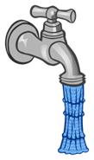
WATER
We learn how to save water at school and at home. We also learn how to help others save water.

ENERGY
We help cut energy costs in school by switching off lights when we leave the room.

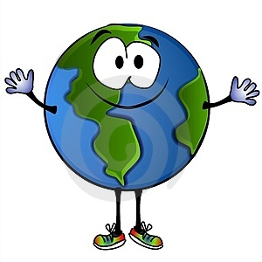

Global citizenship
We try to be aware of how local action has a global impact.

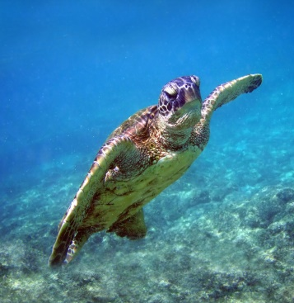
Oceans
We are trying to think about how the environment is affected by our lifestyle choices.

Litter and Waste
We try not to litter and reduce our waste when we can.
Refuse, Reduce, Reuse, Repurpose, Recycle.
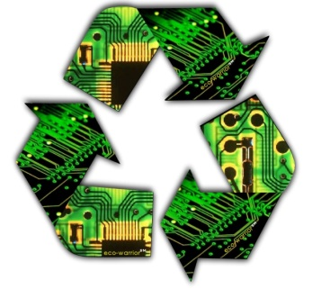
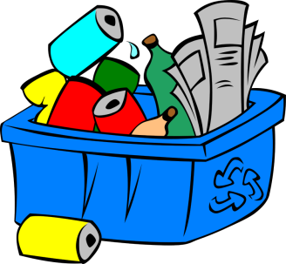
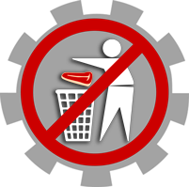

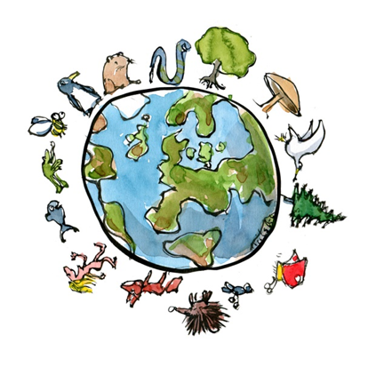

BIODIVERSITY
All living things
We learn how to respect all living things.

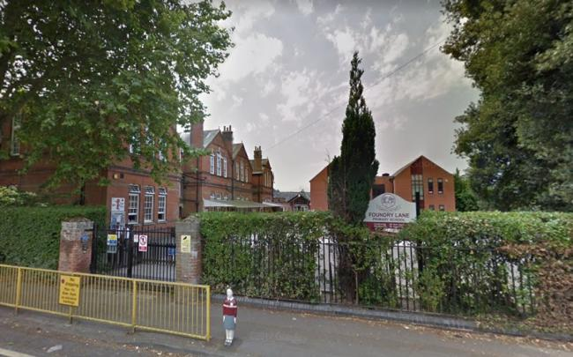
School Grounds
Making our school a better place to be by improving our own environment.

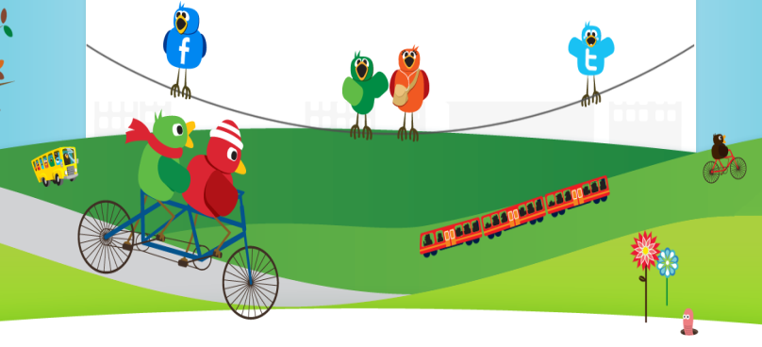
TRAVEL
Making sustainable choices to get to school. Walk, scoot, cycle or use shared transport, like a bus or car share.

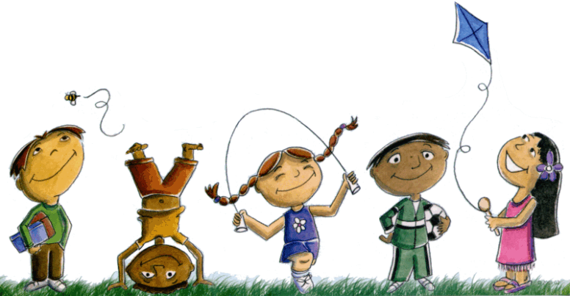

Healthy Living
Making healthy lifestyle choices can also help improve our environment.

