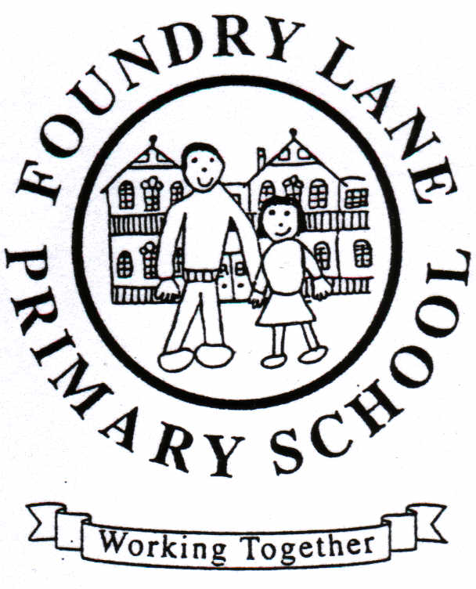
35. GREEN PROCUREMENT POLICY

Statement

Foundry Lane Primary School supports the principles of green procurement and the positive influence it may contribute to conservation and the reduction of damage to our environment.
Wherever possible Foundry Lane Primary School will use locally produced ecologically-friendly resources recognised to be properly processed and manufactured. Primary consideration will be given to the purchase of recycled and recyclable products. Foundry Lane Primary School will endeavour to use environmentally friendly, cost effective, energy efficient technologies that will not have a detrimental effect on the environment and which will in turn reduce the schools carbon footprint.

The following is our guide to green procurement:

Paper - Procurement considerations

- Procure recycled paper based on sustainably harvested virgin fibre.
- Procure paper that is produced through a process of low energy consumption and emissions.
- Avoid bleached paper products.

Cleaning Products - Procurement considerations

- Use cleaning products that are fit for purpose.
- Use chemicals with low toxicity levels.
- Avoid the use of hazardous chemicals.
- Adopt more efficient cleaning plans and techniques.
- Use products with recyclable packaging.
- Use locally produced products wherever possible.
- Use 100% recycled eco certified paper products
- Avoid products with propellants (Use refillable trigger sprays).

Office equipment - Procurement considerations

- Purchase energy efficient equipment.
- Purchase products fabricated with a restricted amount of hazardous materials.
- Purchase products that emit low level noise pollution.
- Purchase products designed for recycling.
- Correctly dispose of any unrecyclable waste products.
- Purchase equipment with low environmental impacts throughout its lifecycle

Lighting - Procurement considerations

- Support LED technology.
- Invest in lighting control systems that will reduce energy consumption.
- Recycle all recyclable waste products
- Correctly dispose of any unrecyclable waste products.

Furniture - Procurement considerations

- Manufactured with timber from legal and sustainably managed forests.
- Use furniture that is partly or totally made from recycled materials.
- Purchase furniture that has come from a recognised ecologically friendly manufacturer.
- Recycle packaging.

Electricity - Procurement considerations

- Increase the share of electricity from renewable energy sources.
- Reduce consumption by adopting more energy efficient technologies.

Gas - Procurement

- Reduce consumption by adopting more energy efficient technologies.
- Ensure TREND systems are utilised properly.

Food and catering services - Procurement considerations

- Purchase food coming at least partially from organic sources.
- Where possible purchase fish that come from a local sustainable source.
- Purchase livestock products that have been subject to high welfare standards.
- Purchase local seasonal products.
- Use products with packaging that has a high recycled content.
- Use of reusable cutlery, crockery, glassware and tablecloths.
- Use 100% recycled eco certified paper products.
- Minimise the use of hazardous chemicals and use environmentally friendly cleaning and dishwashing products.
- Procurement of water and energy efficient kitchen appliances
- Procure locally produced products.

Gardening Services - Procurement considerations

- Avoid the use of peat as a soil improver.
- Limit plant pesticides and use alternative pest control techniques.
- Use locally collected water.
- Use methods to reduce water demand such as mulching.
- Use organically produced and native plants.
- Ensure appropriate materials are composted.
- Procure products in recycled, compostable, reusable, recyclable or biodegradable packaging.

Textiles- Procurement considerations

- Reuse materials that have been purchased.
- Purchase materials that contain recycled fibres.
- Purchase clothes or materials that contain organic cotton or other natural fibres.
- Purchase materials showing the EU organic logo or the international gold standard for organic textiles.

