Our Eco Code !

RESPECT!
Reduce, reuse, Recycle
Eat Healthily
Save Water
Put Rubbish in the correct bin
Everyone can close doors & windows
Care about our environment
Turn off lights when leaving a room

Our Eco Code !

RESPECT!

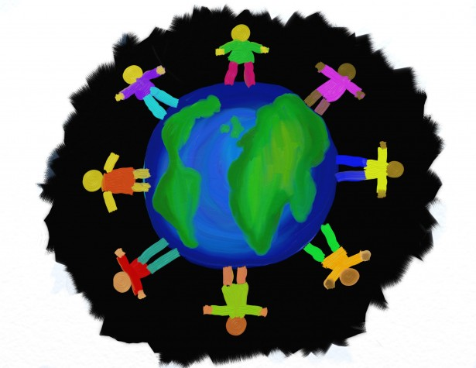
Reduce, reuse, Recycle
Eat Healthily
Save Water
Put Rubbish in the correct bin
Everyone can close doors & windows
Care about our environment
Turn off lights when leaving a room

